**TASKS REPORT**

**Name:- Kundan Keshav Gawande  
 Wipro_id:- 28806**

**DATE:- 09-06-2025**

**Trainer:- Tapan Sir**

**Task 1: Students to analyze the given event viewer logs and investigate the login logout activity**

**Step no.1 :- Open the Event Viewer, Navigate to Windows Logs Under which Select ‘Security’**

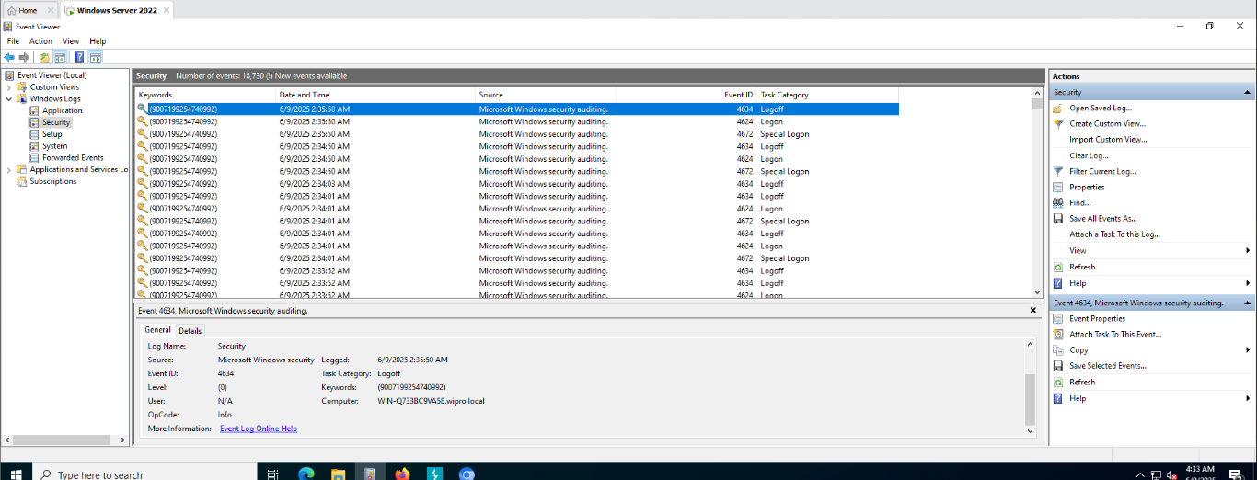

**Step No.2:- Select on the log on Entry Displayed Below**

C:\Users\Y\Desktop\TASK\5.PNG

**Step No.3:- Navigate to ‘General Details’ and Select It , You will get to see details as below**

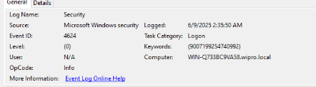

**Step No.4:- Now Select ‘log out’/’logoff’ option as displayed**

C:\Users\Y\Desktop\TASK\6.PNG

**Step No.5:- Navigate to ‘general details’ and Click on it, You will get the following details.**

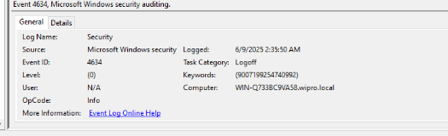

**Task 2: Analyze the given proxy logs to identify the suspicious activity**

**Step No.1:- Open Next DNS on browser , copy the DNS over Https Url**

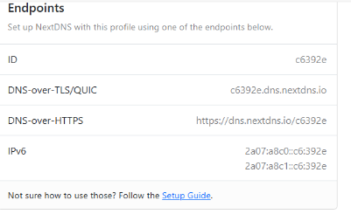

**Step No. 2:- Open Firefox Browser ,Navigate to ‘Settings’ under ‘choose Provider’ paste the DNS Over https url from next DNS**

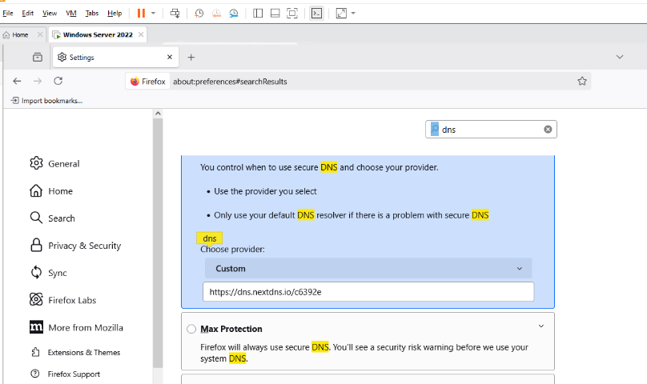

**Step No. 3:- Now in Firefox Browser Open/Visit to any websites/application, You will get to see the logs as displayed Below.**

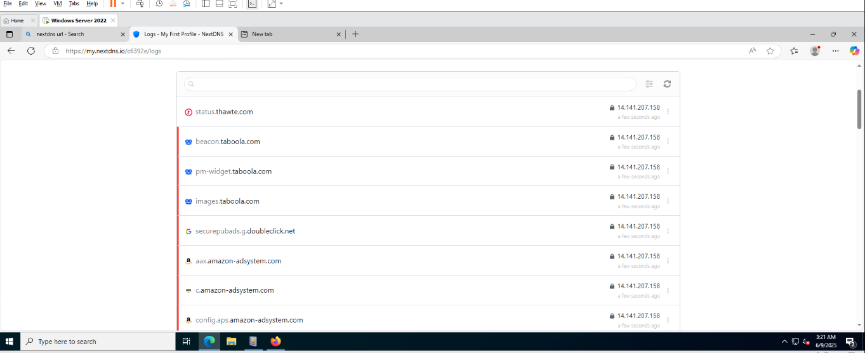

**Task 3: Analyze the given proxy logs to identify access to prohibited social media sites**

**Step No.1:- Open Burp suite**

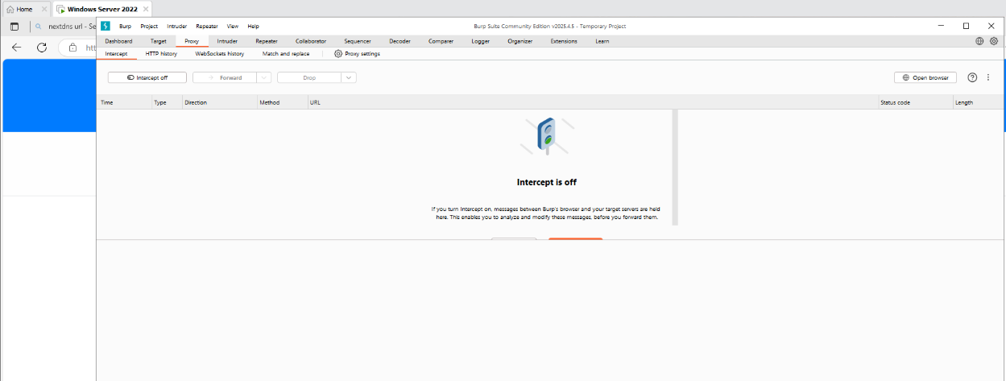

**Step No.2:- Navigate to ‘Proxy’ Option and select it , don’t turn on the intercept. Keep the ‘Intercept off’.**

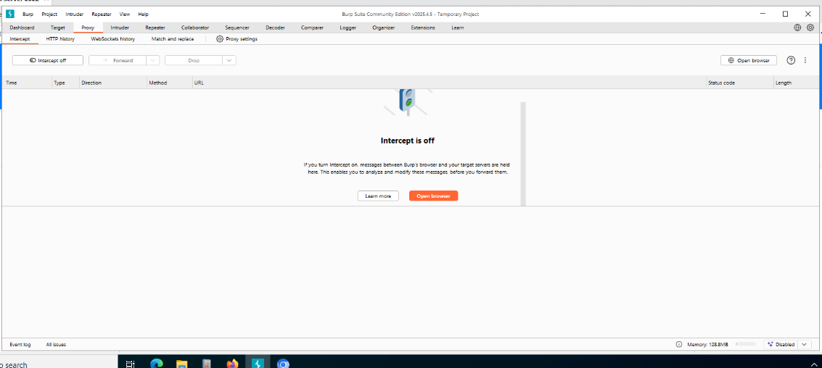

**Step No.3:- Inside the Proxy select the option ‘Open Browser’, this will open browser, Search for “demo.testfire.net”. Sign in and inside search box enter any Script.**

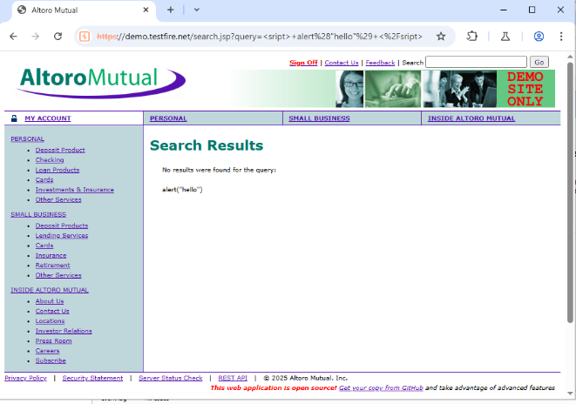

**Step No.4:- Now navigate to ‘Http History’ ,you will get all the details over here**

